Cybersecurity Analyst Internship
Task Report

[samfelix15@gmail.com]
Task No: [17 - E D R]

Copyright © 2024 EncryptEdge Labs. All rights reserved
Credit: Offensive Security

Table of Contents
1.0 EncryptEdge Labs Internship Task Report 2
1.1 Introduction 3
1.2 Objective 4
1.3 Requirements 5
2.0 High-Level Summary 11
2.1 Recommendations 12
2.2 Risk exposure over time 13
3.0 Report - Methodologies 13
3.1 Information Gathering 14
4.0 Additionals Item 15
4.1 Screenshots X
1.0 EncryptEdge Labs Internship Task Report
1.1 Introduction
Endpoint Detection and Response (EDR) technologies have evolved significantly over the past decade, driven by the increasing complexity and sophistication of cyber threats. Initially, endpoint security focused primarily on antivirus software and signature-based detection methods. However, as threats became more advanced, the need for more comprehensive and proactive solutions arose.
EDR solutions emerged as a response to these challenges, offering real-time monitoring, threat detection, and incident response capabilities. These technologies aim to identify and mitigate threats that evade traditional security measures, such as fileless malware, zero-day exploits, and insider threats.
The history of EDR is closely tied to the evolution of endpoint security and the growing recognition of the importance of endpoint protection in overall cybersecurity strategies. Today, EDR is a critical component of many organizations' security architectures, providing the visibility and control needed to detect and respond to endpoint threats effectively.

1.2 Objective
The primary objectives of EDR technologies are to:
1. Detect Advanced Threats: Identify and detect advanced threats, including fileless malware, zero-day exploits, and insider threats, that evade traditional security measures.
2. Provide Real-Time Visibility: Offer real-time visibility into endpoint activity, enabling security teams to monitor and analyze behavior, detect anomalies, and respond to potential threats.
3. Enable Rapid Response: Facilitate rapid response to detected threats, minimizing the impact of security incidents and reducing the risk of data breaches and other adverse outcomes.
4. Improve Incident Response: Enhance incident response capabilities by providing detailed information about security incidents, including the root cause, scope, and impact.
To achieve these objectives, EDR solutions employ various technologies and techniques, such as behavioral analysis, machine learning, and threat intelligence.
Based on the report my main objectives is to
Gain an understanding of the role EDR plays in enhancing security.
Familiarize yourself with Wazuh’s capabilities as an EDR solution.
Create a lab environment to configure Wazuh.
Analyze endpoint activities and generate reports using Wazuh.
Develop a solid understanding of endpoint security concepts and practices. These labs focus on securing endpoints and detecting threats in a networked environment.

1.3 Requirements
Effective EDR solutions require several key components, including:
1. Endpoint Agents: Lightweight agents deployed on endpoints to collect data, monitor activity, and enforce security policies.
2. Data Collection and Analysis: Robust data collection and analysis capabilities to detect and investigate potential threats.
3. Real-Time Monitoring Real-time monitoring of endpoint activity to identify and respond to security incidents as they occur.
4. Threat Intelligence: Integration with threat intelligence feeds to provide context and insights into known threats and tactics, techniques, and procedures (TTPs) used by adversaries.
5. Incident Response: Automated incident response capabilities to quickly contain and mitigate security incidents.
When selecting an EDR solution, organizations should consider factors such as scalability, ease of deployment and management, integration with existing security tools, and the ability to detect and respond to advanced threats.
With reference to this report, I am assigned to,
Write a summary explaining the importance of EDR technologies in securing endpoints and how they fit within a broader security architecture.
Provide a description of the key features Wazuh offers as an EDR solution and how it compares to other EDR tools.
Provide screenshots of the virtual environment setup, Wazuh installation, and configuration of agents.
Submit screenshots of the Wazuh dashboard, showing the detection of simulated incidents and the responses triggered.
Provide sample reports generated from Wazuh, including key findings on endpoint activities and any notable security events.
In this task tools that would be used will include
EDR solution: Wazuh
Virtualization software: (e.g., VirtualBox, VMware)
Sample endpoints for configuration exercises

Wazuh as an EDR Solution
Wazuh is an open-source EDR solution that provides real-time monitoring, threat detection, and incident response capabilities. Key features of Wazuh include:
Real-Time Monitoring: Wazuh provides real-time monitoring of endpoint activity, enabling security teams to detect and respond to potential threats.
Behavioral Analysis: Wazuh uses behavioral analysis to detect advanced threats, including fileless malware and zero-day exploits.
Threat Intelligence: Wazuh integrates with threat intelligence feeds to provide context and insights into known threats and TTPs used by adversaries.
Incident Response: Wazuh provides automated incident response capabilities to quickly contain and mitigate security incidents.
Compliance : Wazuh provides compliance features, including support for regulatory requirements and industry standards.

Wazuh offers several benefits, including:
Cost-Effective: Wazuh is an open-source solution, making it a cost-effective option for organizations.
Customizable: Wazuh is highly customizable, enabling organizations to tailor the solution to their specific security needs.
Scalable: Wazuh is designed to scale, making it suitable for large and complex environments.

Comparison to Other EDR Tools
Wazuh compares favorably to other EDR tools, including:
CrowdStrike: CrowdStrike is a popular EDR solution that provides real-time monitoring and threat detection capabilities. While CrowdStrike is a powerful solution, it can be expensive, especially for large environments.
Carbon Black: Carbon Black is another well-known EDR solution that provides real-time monitoring and threat detection capabilities. While Carbon Black offers advanced features, it can be complex to deploy and manage.
FireEye: FireEye is a comprehensive EDR solution that provides real-time monitoring, threat detection, and incident response capabilities. While FireEye offers advanced features, it can be expensive and complex to deploy.
Cost: Wazuh is an open-source solution, making it a cost-effective option for organizations. Other EDR tools, such as CrowdStrike and FireEye, can be more expensive, especially for large environments.
Complexity: Wazuh is designed to be easy to deploy and manage, while other EDR tools, such as Carbon Black, can be more complex to implement and require specialized expertise.
Customization: Wazuh is highly customizable, enabling organizations to tailor the solution to their specific security needs. Other EDR tools may offer more limited customization options.
Scalability: Wazuh is designed to scale, making it suitable for large and complex environments. Other EDR tools may also offer scalability features, but may require more resources and expertise to implement.
Key Features of Wazuh
Some key features of Wazuh include:
Real-Time Monitoring: Wazuh provides real-time monitoring of endpoint activity, enabling security teams to detect and respond to potential threats.
Behavioral Analysis : Wazuh uses behavioral analysis to detect advanced threats, including fileless malware and zero-day exploits.
Threat Intelligence: Wazuh integrates with threat intelligence feeds to provide context and insights into known threats and TTPs used by adversaries.
Incident Response: Wazuh provides automated incident response capabilities to quickly contain and mitigate security incidents.

Benefits of Using Wazuh
The benefits of using Wazuh include:
Improved Threat Detection: Wazuh's behavioral analysis and threat intelligence capabilities enable organizations to detect advanced threats that may evade traditional security measures.
Enhanced Incident Response: Wazuh's automated incident response capabilities enable organizations to quickly respond to security incidents and minimize the impact of breaches.
Increased Visibility: Wazuh provides detailed visibility into endpoint activity, enabling security teams to monitor and analyze behavior, detect anomalies, and respond to potential threats.
Cost-Effective: Wazuh is an open-source solution, making it a cost-effective option for organizations.
Future Anticipations Of Using EDR
As the threat landscape continues to evolve, EDR solutions like Wazuh will play an increasingly important role in protecting organizations from advanced threats. Future directions for Wazuh and other EDR solutions may include:
Integration with Other Security Tools: Integrating EDR solutions with other security tools, such as SIEM systems and threat intelligence platforms, to provide a more comprehensive view of security threats.
Artificial Intelligence and Machine Learning: Leveraging artificial intelligence and machine learning to improve threat detection and incident response capabilities.
Cloud-Based Solutions: Developing cloud-based EDR solutions that can be easily deployed and managed in cloud environments.
Increased Adoption of Artificial Intelligence and Machine Learning: EDR solutions will increasingly leverage artificial intelligence and machine learning to improve threat detection and incident response capabilities.
Greater Emphasis on Cloud Security: As more organizations move to the cloud, EDR solutions will need to be designed to protect cloud-based infrastructure and applications.
Integration with Other Security Tools: EDR solutions will need to integrate seamlessly with other security tools, such as SIEM systems and threat intelligence platforms, to provide a comprehensive view of security threats.
Improved Automation and Orchestration: EDR solutions will need to provide improved automation and orchestration capabilities to enable organizations to respond quickly and effectively to security incidents.
By staying ahead of the curve and leveraging the latest technologies and techniques, EDR solutions like Wazuh can help organizations protect themselves from the ever-evolving threat landscape. ‎
Challenges and Opportunities
The adoption of EDR solutions also presents several challenges and opportunities, including:
Complexity: Implementing and managing EDR solutions can be complex, requiring specialized expertise and resources.
Data Overload: EDR solutions can generate large amounts of data, which can be challenging to analyze and prioritize.
False Positive: EDR solutions can generate false positives, which can lead to wasted resources and decreased effectiveness.
Opportunity for Innovation: The challenges associated with EDR solutions also present opportunities for innovation and improvement, such as the development of more advanced threat detection and incident response capabilities.
Best Practices for Implementing EDR Solutions
To get the most out of EDR solutions, organizations should follow best practices for implementation, including:
Clearly Define Requirements: Clearly define the requirements for the EDR solution, including the types of threats to be detected and the incident response capabilities needed.
Choose the Right Solution: Choose an EDR solution that meets the organization's specific needs and requirements.
Implement and Configure the Solution: Implement and configure the EDR solution, including setting up data collection and analysis capabilities.
Monitor and Analyze Data: Continuously monitor and analyze data from the EDR solution to detect and respond to potential threats.
Continuously Improve: Continuously improve the EDR solution, including updating threat detection capabilities and incident response processes.
By following these best practices, organizations can ensure that their EDR solution is effective and provides the necessary protection against advanced threats.

2.0 High-Level Summary
In conclusion, Wazuh is a powerful EDR solution that provides real-time monitoring, threat detection, and incident response capabilities. Its open-source nature makes it a cost-effective option for organizations, while its customization features enable organizations to tailor the solution to their specific security needs. By implementing Wazuh, organizations can improve their threat detection and incident response capabilities, while also increasing visibility into endpoint activity.
EDR technologies are critical for securing endpoints and detecting advanced threats that evade traditional security measures. By providing real-time visibility, threat detection, and incident response capabilities, EDR solutions enable organizations to respond quickly to security incidents and minimize the risk of data breaches and other adverse outcomes.
In conclusion, EDR solutions are a crucial component of modern cybersecurity strategies, providing real-time monitoring, threat detection, and incident response capabilities. By understanding the benefits and challenges of EDR solutions, organizations can make informed decisions about implementation and ensure that their solution is effective in protecting against advanced threats. ‎

2.1 Recommendations
Based on the importance of EDR in securing endpoints and the benefits it offers, I recommend that organizations:
1. Implement EDR Solution: Deploy EDR solutions that provide real-time monitoring, threat detection, and incident response capabilities.
2. Integrate with Existing Security Tools: Integrate EDR solutions with existing security tools, such as SIEM systems, threat intelligence platforms, and incident response tools.
3. Provide Training and Awareness: Provide training and awareness programs for security teams and end-users to ensure effective use of EDR solutions and promote a culture of security.
4. Continuously Monitor and Evaluate: Continuously monitor and evaluate EDR solutions to ensure they remain effective and aligned with evolving security needs.
By following these recommendations, organizations can enhance their endpoint security posture and improve their ability to detect and respond to endpoint threats.

2.2 Risk Exposure over Time
The risk exposure associated with endpoint security has increased significantly over time, driven by several factors:
1. Growing Attack Surface: The proliferation of endpoints, including laptops, desktops, mobile devices, and IoT devices, has expanded the attack surface, providing more opportunities for attackers to exploit vulnerabilities.
2. Sophisticated Threats: The increasing sophistication of threats, including fileless malware, zero-day exploits, and advanced persistent threats (APTs), has made it more challenging for traditional security measures to detect and respond to endpoint threats.
3. Changing Threat Landscape: The threat landscape is constantly evolving, with new threats and attack vectors emerging regularly. EDR solutions must be able to adapt to these changes and detect unknown threats.
4. Regulatory Requirements: Organizations face growing regulatory requirements and compliance obligations related to endpoint security, making it essential to implement effective EDR solutions.
To mitigate these risks, organizations must prioritize endpoint security and implement EDR solutions that provide real-time visibility, threat detection, and incident response capabilities.

3.0 Methodologies
Implementing an effective EDR solution requires a comprehensive methodology that includes:
1. Assessment and Planning: Assess the organization's current security posture and plan the implementation of the EDR solution.
2. Deployment: Deploy the EDR solution, including installing agents on endpoints and configuring the solution to meet the organization's security needs.
3. Configuration and Tuning: Configure and tune the EDR solution to optimize its effectiveness and minimize false positives.
4.Monitoring and Analysis: Continuously monitor and analyze endpoint activity to detect and respond to potential threats.
5. Incident Response: Develop and implement incident response procedures to quickly respond to security incidents detected by the EDR solution.

3.1 Information Gathering
Based on this report my information was gathered based on acquired knowledge through research and consistent in depth findings and provided useful resources, link, Youtube videos, cheat sheets, articles provided to my EncryptEdgeLabs. Some of these articles are outlined below
Articles:
Understanding Endpoint Detection and Response (EDR)
Understanding Wazuh: An All-in-One Cybersecurity Solution
Wazuh Configuration for Vulnerabilities Detection at Endpoints
Setting Up an EDR with Email Alerts: Wazuh
6 Steps to Integrating EDR in Your IT Department

Also, to add to that ,effective EDR solutions require the collection and analysis of various types of data, including:
Endpoint Data: Collect data from endpoints, including logs, network traffic, and system calls.
Threat Intelligence: Integrate with threat intelligence feeds to provide context and insights into known threats and TTPs used by adversaries.
Security Information
detection systems.
By gathering and analyzing this data, EDR solutions can provide a comprehensive view of endpoint activity and detect potential threats.

4.0 Additional Items
4.1 Screenshots
This section will include collated screenshots on Wazur installation process and completed lab assignments on the TryHackMe platform. This will include screenshots of
Intro to Endpoint security and Wazuh Lab
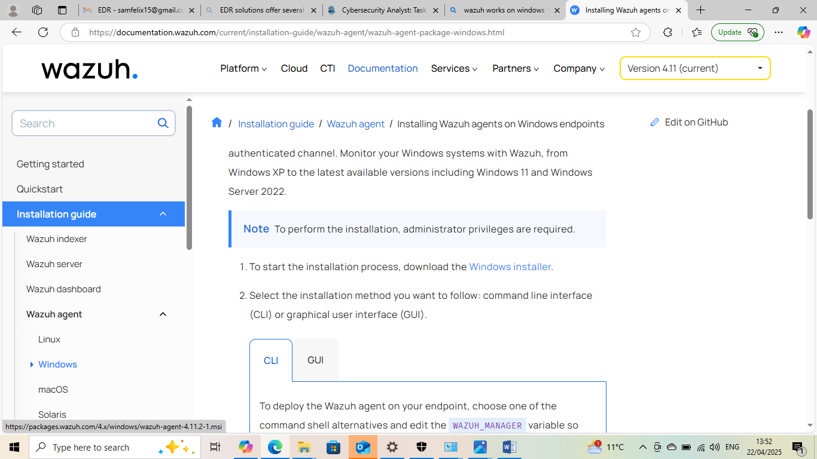
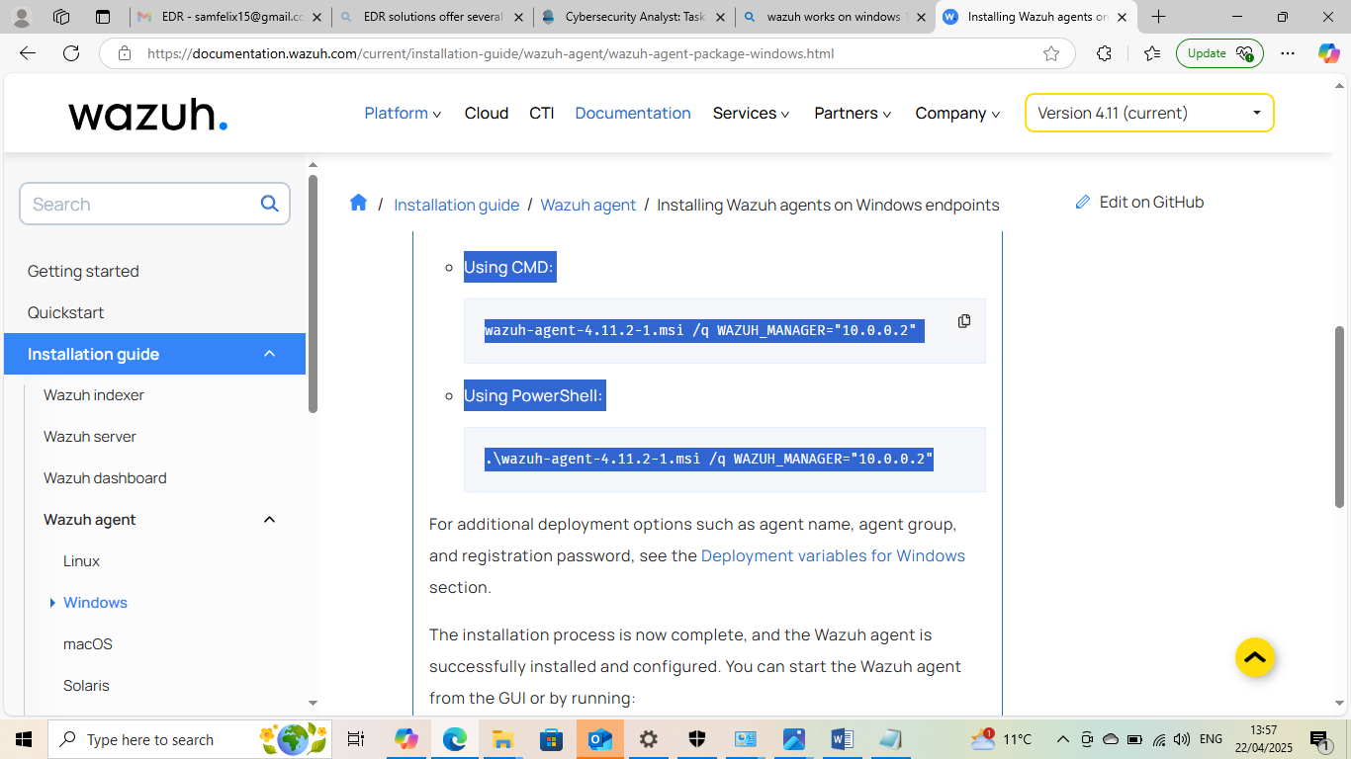

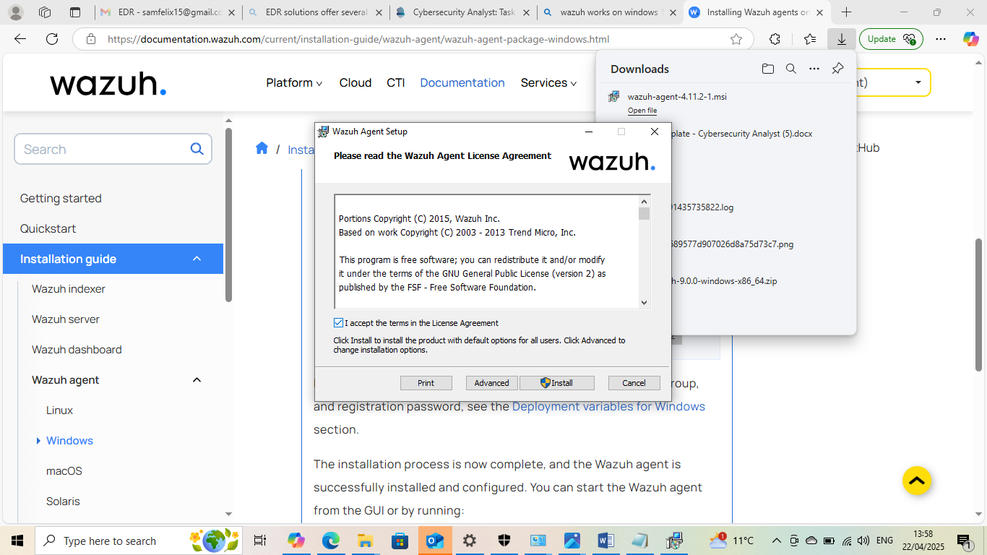



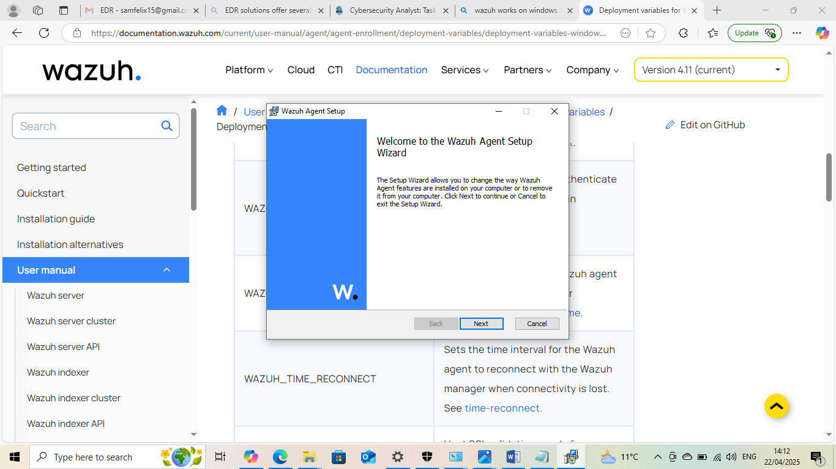






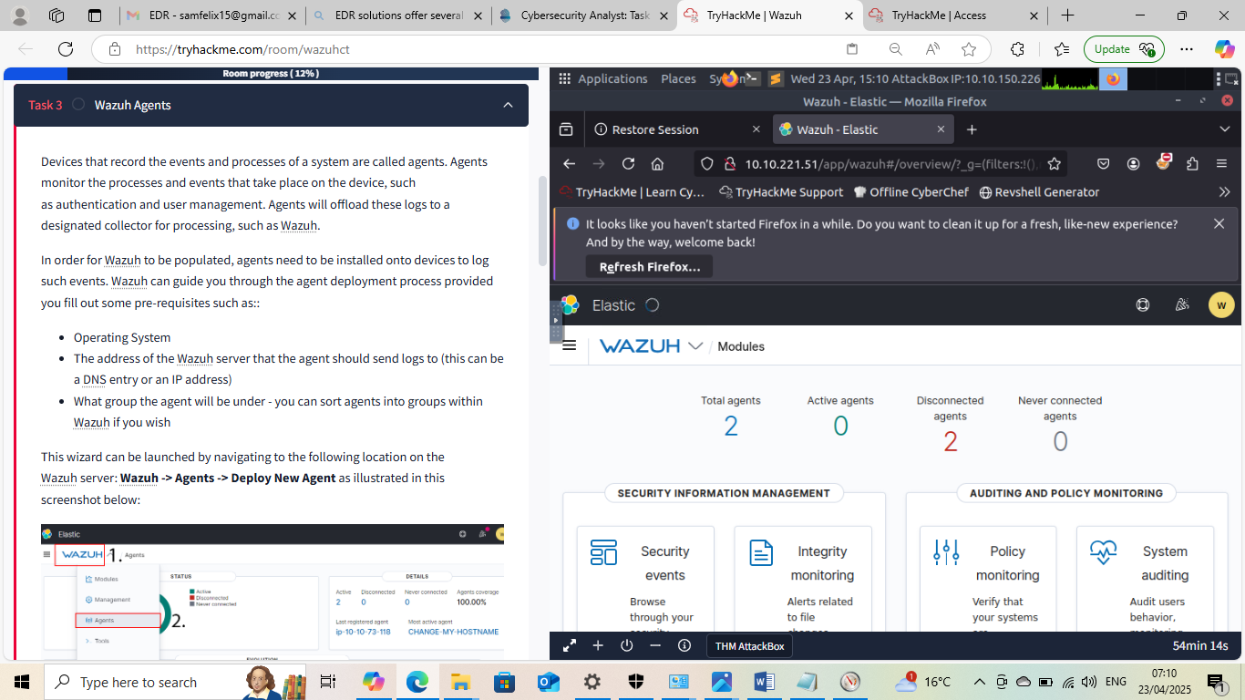



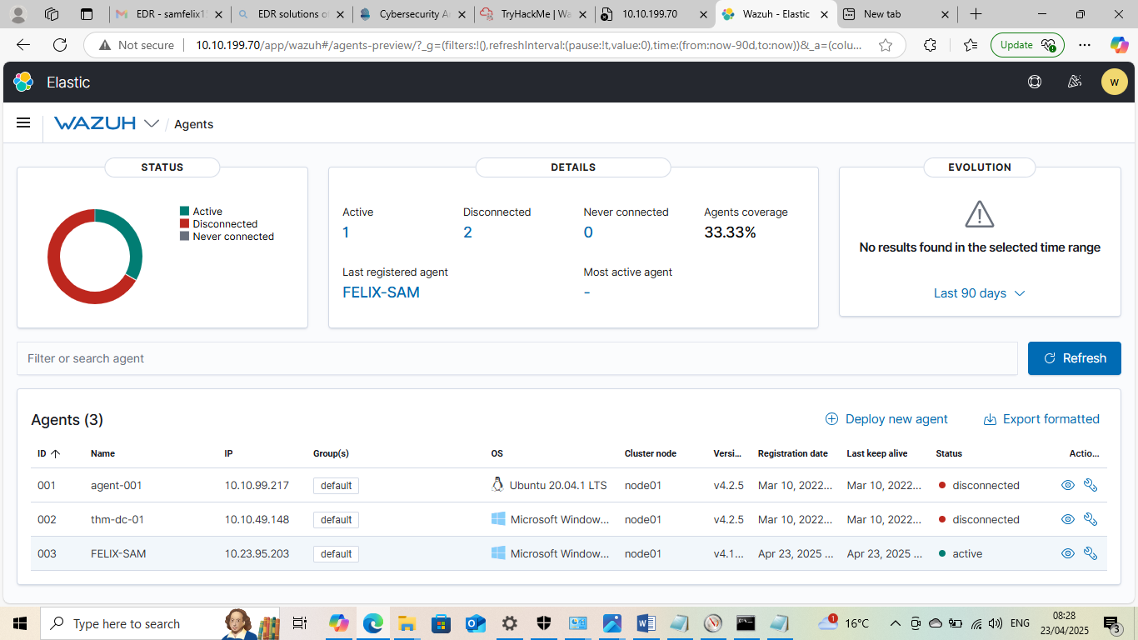

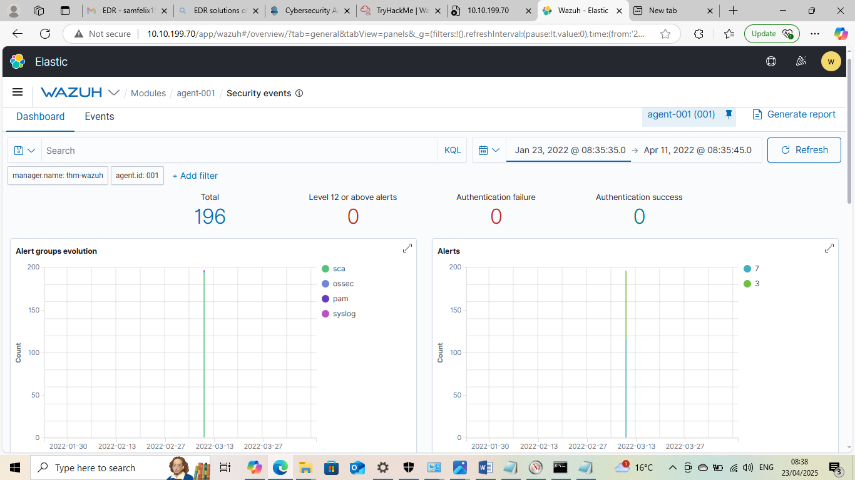

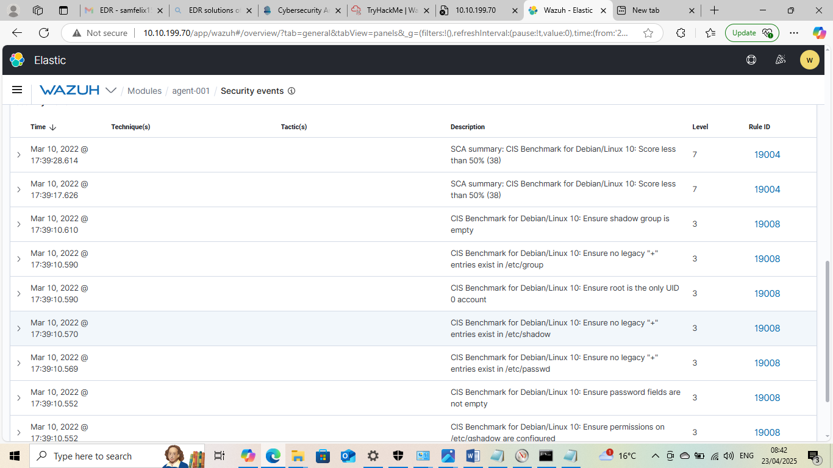

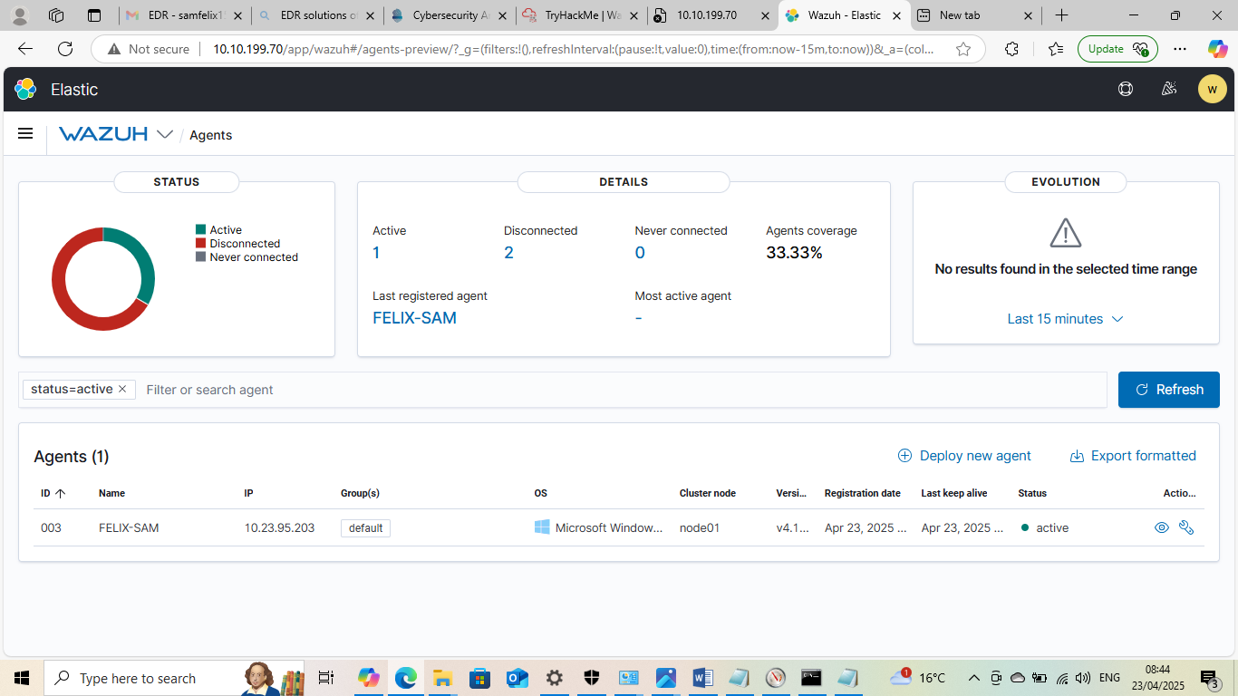



THANK YOU

This Internship Task report was developed on [April, 23, 2025]

By:
[ samfelix15@gmail.com ]

